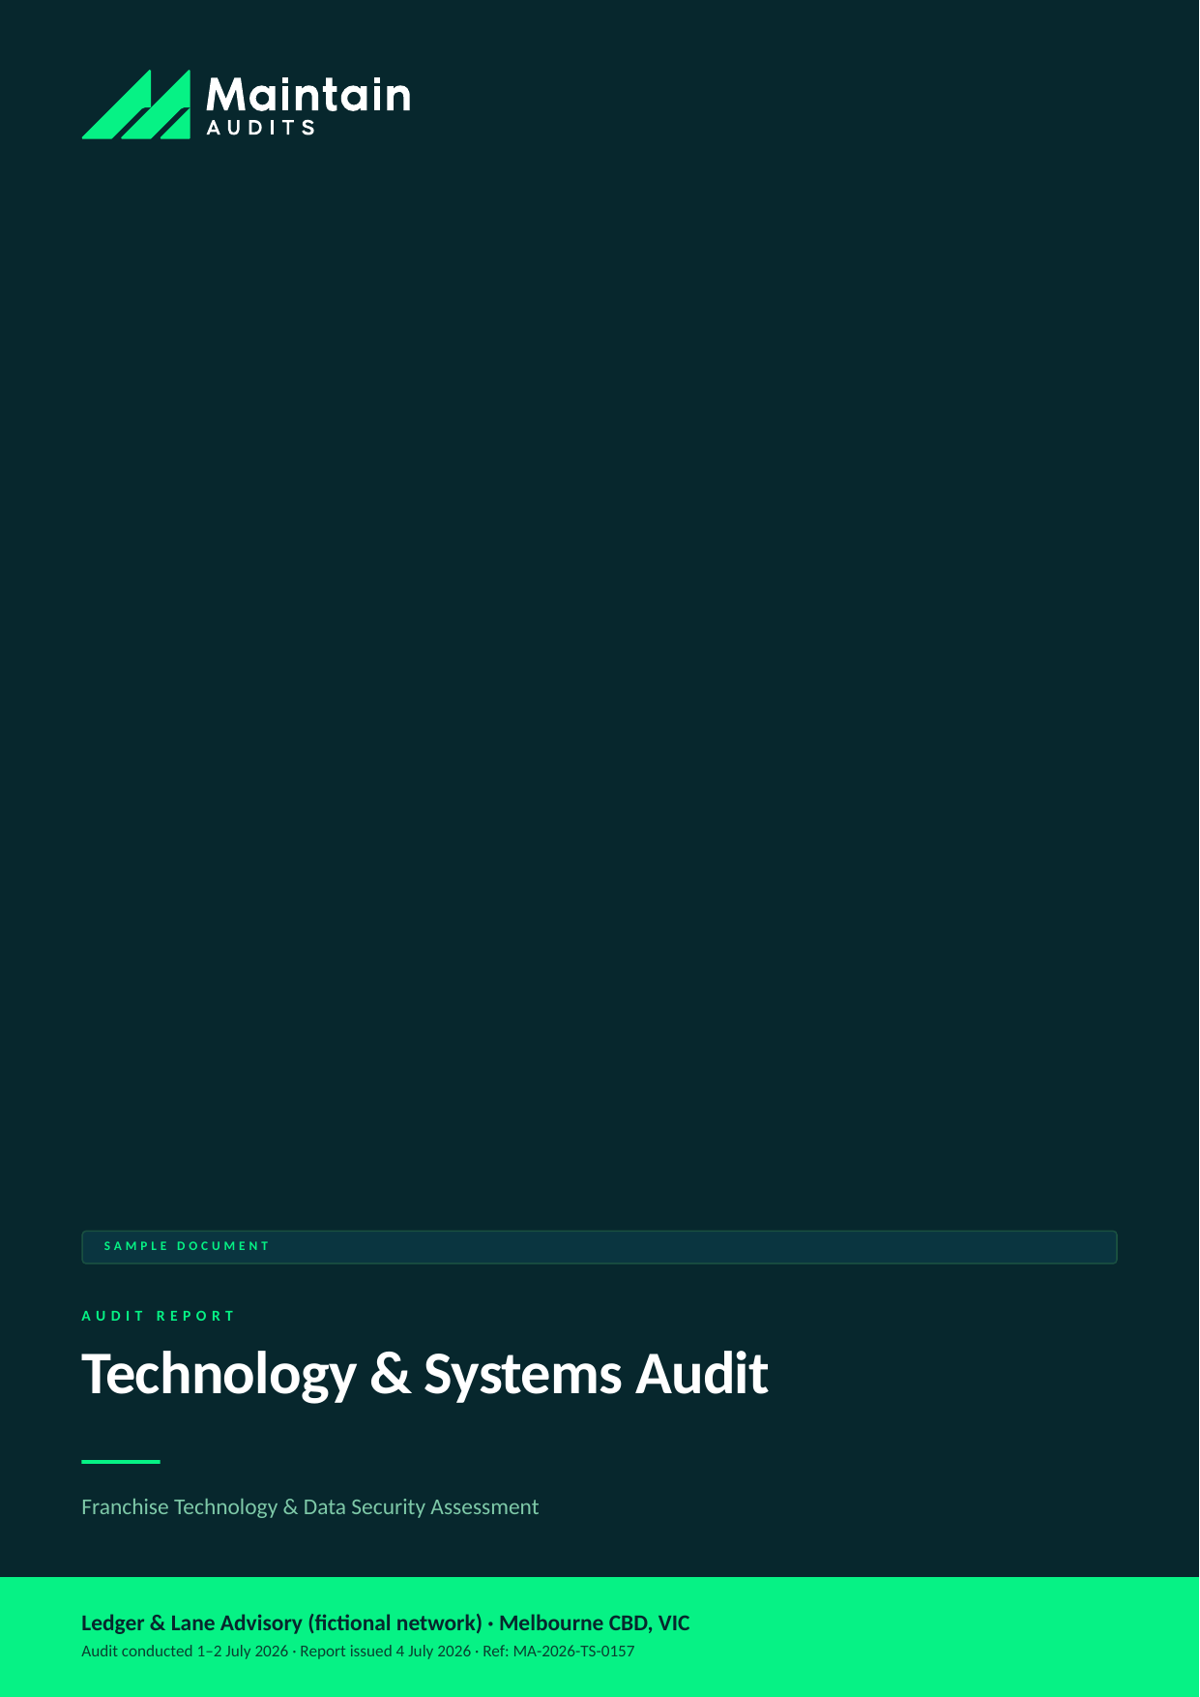

Client (fictional) | Ledger & Lane Advisory (fictional network)
Location | Melbourne CBD, VIC — franchise office
Audit type | Technology & Systems Audit
Audit conducted | 1–2 July 2026
Report issued | 4 July 2026 (48-hour turnaround)
Lead auditor | A. Whitford, Technology Auditor — Maintain Audits
Report reference | MA-2026-TS-0157
Distribution | Franchisor head office; franchisee principal — Commercial in confidence

SAMPLE DOCUMENT — all client details and findings are fictional, prepared to demonstrate Maintain Audits' reporting format.

SECTION 1 │ EXECUTIVE SUMMARY

This technology and systems audit assessed the Melbourne CBD office of the Ledger & Lane advisory franchise against the network technology standard — covering practice management systems, client data security, access control, backup, and business continuity. For a professional services franchise holding sensitive client financial data, technology assurance is client-trust assurance.
The office scored 66% against the network standard. The most serious findings: client files stored in a personal cloud-storage account outside the network tenancy, shared login credentials for the practice management system (destroying the audit trail), and multi-factor authentication disabled for three staff accounts including one with full client-data access.
None of these findings indicate misconduct — they are convenience habits that accumulated without review. But in a data-incident scenario, each would convert directly into regulatory exposure and client harm. All can be closed within 30 days, and most within 7.

Overall Result
Measure | Result
Overall compliance score | 66% against network technology standard (target ≥ 85%)
Overall rating | High
Findings raised | 6
Most urgent action due | Migrate client files from personal cloud account (TS-01) — begin within 48 hours

Findings by Risk Rating
Rating | Count
Critical | 2
High | 2
Medium | 2

SECTION 2 │ SCOPE & METHODOLOGY

An assessment of the office's technology stack, data security posture, and systems usage against the Ledger & Lane Network Technology Standard v4 and the network's obligations under the Privacy Act (APPs).

In Scope
- Practice management and document systems — configuration, access control, audit trails
- Client data storage locations, encryption, and retention
- Identity and access — account hygiene, MFA, offboarding, password practices
- Backup and recovery — coverage, testing, restore capability
- Endpoint and network security — device management, patching, office network configuration
- Business continuity and incident readiness

How the Audit Was Conducted
- Two-day on-site and remote-configuration audit
- Configuration review of the practice management platform, network tenancy, and endpoint fleet (11 devices)
- Access and account review against the current staff list, including departed-staff check
- Backup verification including a supervised test restore
- Interviews with the principal, practice manager, and the office's external IT provider

Risk Rating Scale
Rating | Meaning | Action required
Critical | Immediate threat to safety, legal compliance, or brand integrity. | Within 48 hours
High | Material non-compliance likely to cause customer, safety, or financial impact. | Within 7 days
Medium | Non-compliance with franchise standards; manageable if addressed promptly. | Within 30 days
Low | Minor deviation or housekeeping issue. | Within 90 days
Observation | Not a non-compliance; an improvement opportunity worth acting on. | At next review

SECTION 3 │ FINDINGS SUMMARY

ID | Area | Finding | Rating
TS-01 | Data storage | Client files in a personal cloud-storage account | Critical
TS-02 | Access control | Shared login for the practice management system | Critical
TS-03 | Identity security | MFA disabled on three accounts including full-access user | High
TS-04 | Offboarding | Two departed staff retained active accounts and email forwarding | High
TS-05 | Backup & recovery | Backups running but never test-restored; local NAS unencrypted | Medium
TS-06 | Endpoints & patching | Three laptops outside device management and behind on patches | Medium

SECTION 4 │ DETAILED FINDINGS

CRITICAL | TS-01 — Client files in a personal cloud-storage account

Rating | Area | Standard / reference | Remediate by
Critical | Data storage | Network tech std 3.1; Privacy Act APP 11 | Begin within 48 hours; complete within 14 days

What we found: Approximately 60GB of client working files — including financial statements and identity documents — are stored in a personal consumer cloud account belonging to a senior staff member, shared to colleagues via link. The account sits outside the network tenancy: no encryption policy, no audit trail, no offboarding control, and links that anyone can forward.
Evidence: Storage location review with practice manager; sharing-link audit; sample content verification (supervised).
Recommended action: Freeze new use immediately, migrate contents to the network document system within 14 days, then verify deletion from the personal account. Communicate the 'client data lives only in network systems' rule to all staff in writing.
Responsible: Principal / IT provider

CRITICAL | TS-02 — Shared login for the practice management system

Rating | Area | Standard / reference | Remediate by
Critical | Access control | Network tech std 4.2 | Within 7 days

What we found: Four staff share a single 'office' login to the practice management platform. Every action against client records is therefore unattributable — the audit trail, a key control for a financial services adjacent practice, is effectively destroyed. The shared password was also written on a note under the reception keyboard.
Evidence: Account review; usage log analysis; photo 022 (password note, redacted).
Recommended action: Provision individual licensed accounts for all four staff, retire the shared login, and rotate all passwords. The licence cost (~$180/month) is immaterial against the control value.
Responsible: Practice manager / IT provider

HIGH | TS-03 — MFA disabled on three accounts including full-access user

Rating | Area | Standard / reference | Remediate by
High | Identity security | Network tech std 4.1 | Within 48 hours

What we found: Multi-factor authentication is enforced by network policy but was found disabled via exception on three accounts — disabled 'temporarily' during a phone migration in February and never re-enabled. One account holds full client-data access and its password appears in a public breach corpus.
Evidence: Tenancy security report; breach-corpus check (HIBP) with principal's consent.
Recommended action: Re-enable MFA on all accounts today, reset the breached credential, and remove the ability for local exceptions to be granted without network IT approval.
Responsible: IT provider

HIGH | TS-04 — Two departed staff retained active accounts and email forwarding

Rating | Area | Standard / reference | Remediate by
High | Offboarding | Network tech std 4.4 | Within 48 hours

What we found: Accounts for two staff who left in March and May 2026 remained active, one with a mailbox rule silently forwarding client correspondence to a personal address — most likely set up legitimately for handover and never removed.
Evidence: Account list vs staff register; mailbox rule audit.
Recommended action: Disable both accounts and remove the forwarding rule immediately; review the forwarded mail scope and take advice on whether notification obligations arise. Adopt the network's offboarding checklist as a same-day requirement at every departure.
Responsible: Principal / IT provider

MEDIUM | TS-05 — Backups running but never test-restored; local NAS unencrypted

Rating | Area | Standard / reference | Remediate by
Medium | Backup & recovery | Network tech std 5.2 | Within 30 days

What we found: Cloud backup of the network tenancy is healthy, but the office's supplementary NAS backup is unencrypted, sits under a desk in the open-plan office, and no restore has ever been tested. Our supervised test restore succeeded from cloud but failed from the NAS (corrupted index).
Evidence: Backup configuration review; test restore records both targets.
Recommended action: Either bring the NAS under the standard (encrypted, secured, tested quarterly) or retire it and rely on the compliant cloud backup. Schedule quarterly test restores with logged results.
Responsible: IT provider

MEDIUM | TS-06 — Three laptops outside device management and behind on patches

Rating | Area | Standard / reference | Remediate by
Medium | Endpoints & patching | Network tech std 6.1 | Within 30 days

What we found: Three of eleven endpoints — personal laptops used by part-time staff — are not enrolled in the network's device management, are 4–7 months behind on OS security patches, and have no disk encryption verified. All three access client data.
Evidence: Device inventory vs management console; patch level check.
Recommended action: Enrol the devices (or supply managed devices) before continued client-data access. The network standard permits BYOD only under management enrolment.
Responsible: IT provider / practice manager

SECTION 5 │ WHAT'S WORKING WELL

An audit should recognise strength as clearly as it flags risk. The following practices met or exceeded the network standard:

- The network tenancy itself is well configured — email security (SPF/DKIM/DMARC), anti-phishing policies, and cloud backup all met the standard
- The practice management platform is current, vendor-supported, and correctly firewalled from the guest network
- Staff security awareness was better than the findings imply — the team knew the right answers; the systems just hadn't been held to them
- The external IT provider was responsive and engaged constructively with every finding during the audit

SECTION 6 │ REMEDIATION ROADMAP

Actions are sequenced by risk. Maintain Audits can verify closure of each item through a follow-up desktop review or re-inspection.

ID | Action | Owner | Due
TS-01 | Migrate client files to network tenancy; verify deletion; issue data-location policy | Principal / IT provider | Begin 48 hrs; complete 14 days
TS-02 | Individual accounts provisioned; shared login retired; passwords rotated | Practice manager / IT provider | Within 7 days
TS-03 | Re-enable MFA; reset breached credential; lock exception policy | IT provider | Within 48 hours
TS-04 | Disable departed accounts; remove forwarding; assess notifications; adopt offboarding checklist | Principal / IT provider | Within 48 hours
TS-05 | Remediate or retire NAS; quarterly test-restore schedule | IT provider | Within 30 days
TS-06 | Enrol or replace unmanaged endpoints | IT provider / practice manager | Within 30 days

SECTION 7 │ NEXT STEPS & ONGOING MONITORING

- TS-01 to TS-04 closure evidence to Maintain Audits within 14 days; we will verify by remote configuration review
- Recommend a network-wide version of this audit — the convenience-drift pattern found here is rarely confined to one office
- A 6-month follow-up review is recommended to confirm controls have held, timed to the network's insurance renewal

Questions about this report: info@maintainaudits.com.au · +61 414 530 836 · maintainaudits.com.au

This report is a sample document prepared by Maintain Audits, a division of Maintain Technology, for demonstration purposes. All client names, locations, personnel, and findings are fictional. Actual audit reports are prepared under our engagement terms and are confidential to the client. This document does not constitute legal, financial, or professional compliance advice.

